Fall 2024

Message from the President Elect, Nick Solomon:

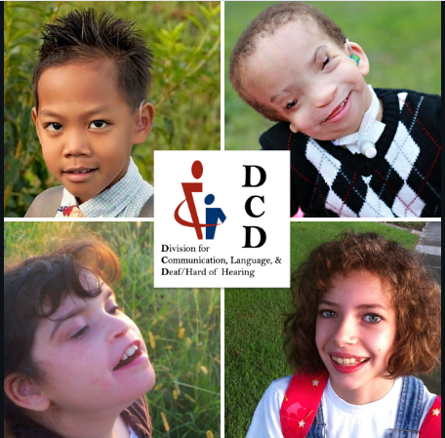

DCD Website

DCD has a new website!

Click on the link to check it out!

<https://dcd.exceptionalchildren.org/>

Know someone who would like to be a member?

Join us!

[Click here to join DCD!](https://docs.google.com/forms/d/12YEC0GlvlZ9GClS8XTAv3Fpic4UOAJnMEuDXOzpKIJQ/viewform?edit_requested=true)

Constituent Connect:

Kameron Carden, Ph.D., CCC/SLP, LSLS Cert. AVEd.,

DCD Constituent Chair for Deaf/Hard of Hearing

The field of deaf education has undergone significant transformations across the past two decades. For many young children many young children who are deaf/hard of hearing (D/HH) using listening and spoken language (LSL), improved hearing technology and earlier access to quality early intervention services have resulted in improved spoken language outcomes. These two drivers have, in turn, resulted in a sort of caseload transformation for many deaf education practitioners. For example, one cascading effect of these improved outcomes is that many children are not qualifying for continued services at age 3 during the IDEA (2004) Part C to Part B transition due to norm-referenced language performance within the average range. However, rather than reducing the special education needs of young children who are D/HH, technological and early intervention advancements have merely changed the nature of how we must identify those needs. The observed reduction in eligibility actually results from a research-to-practice gap in adopting evidence-based assessment practices aligned with the purpose of a special education eligibility evaluation rather than decreased need for continued services under IDEA (2004). Specifically, preschoolers who are D/HH using LSL often demonstrate global language skills within 1.5 *SDs* of the mean on norm-referenced global language measures (Tomblin et al., 2015; Werfel & Douglas, 2017). However, they often still exhibitevidence of language delays and disruptions in more naturalistic language contexts (Koehlinger et al., 2013; Schiller et al., 2022; Werfel & Douglas, 2017; Werfel et al., 2021). Although norm-referenced language measures used for evaluations have demonstrated a lack of sensitivity and specificity (Spaulding et al., 2006; Werfel & Douglas, 2017), many school-based practitioners continue to primarily rely upon them when making diagnostic and eligibility determinations for services (Fulcher-Rood et al., 2018; Hallam et al., 2014).

As an alternative, the literature consistently demonstrates that language sample analysis (LSA) is a more sensitive measure of detecting language delays and disruptions in young children who are D/HH (Koehlinger et al., 2013; Werfel, 2018; Werfel & Douglas, 2017; Werfel et al., 2021). The reliance on norm-referenced measures rather than LSA for evaluation demonstrates a research-to-practice gap that is consistent with national trends (Blaiser & Shannahan, 2018; Pavelko et al., 2016). The gap widens when considering how school-based evaluation practices align with evaluation guidance across all developmental domains for children who are D/HH from the National Association for State Directors of Special Education (NASDSE, 2018). A recent survey study of 149 school-based special education practitioners found that special education teachers, SLPs, and teachers of the deaf are consistently following recommended practices for the quantity of developmental assessments used, but the evidence-based quality of those assessments is often lacking, particularly for language assessments (Carden et al., 2023).

Given that insufficient time is a significant barrier to evidence-based assessment practices, particularly in schools (Fulcher-Rood et al., 2018; Greenwell & Walsh, 2021), Kameron Carden, Kristina Blaiser, and their colleagues (2024) have assimilated evidence-based practices (EBP) from the literature for young children who are D/HH using LSL that align with NASDSE’s evaluation guidance to create a sensitive, feasible framework. Based on NASDSE’s (2018) guidance, the literature, and the minimum evaluative requirements shared by most states for a determination under *deaf/hard of hearing*, this evaluation checklist is intended to aid educational teams in balancing assessment sensitivity and feasibility for young preschoolers who are D/HH using LSL, particularly those 30 to 35 months of age being evaluated during the IDEA (2004) Part C to B transition period. You can retrieve the open-access evaluation checklist here: <https://doi.org/10.23641/asha.26359642>*. The checklist includes hyperlinks to multiple evidence-based evaluation tools to increase school-based practitioners’ access to specialized assessment tools designed for preschoolers who are D/HH. The checklist also includes a framework for analyzing language samples to detect and determine adverse effects of a hearing difference on equitable access to age-appropriate activities in the preschool setting.

Kameron and Kristina are proud to serve on the DCD board, and they believe that their work to create an evaluation checklist has the potential to be a springboard for closing a significant research-to-practice gap in the initial gatekeeping process of evaluation for special education eligibility. Closing this gap could positively impact preschoolers who are DHH using LSL by ensuring they receive the support they need to fully access participation in age-appropriate activities during the preschool years and beyond. If you have any questions about the checklist, please reach out to Kameron ([kcarden1@samford.edu](mailto:kcarden1@samford.edu)) or Kristina ([Kristina.blaiser@isu.edu](mailto:Kristina.blaiser@isu.edu)) and they will be happy to chat!

*The open-access checklist is part of a larger paper: Carden, K. C., Blaiser, K. M., Brooks, B. M., & McWilliam, R. A. (2024). Evidence-based practices for evaluating preschoolers who are deaf/hard of hearing using listening and spoken language for special education eligibility. *Perspectives of the ASHA Special Interest Groups*, 1–21. <https://doi.org/10.1044/2024_persp-24-00081>.

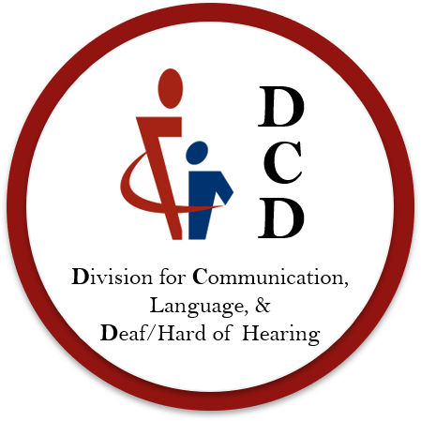

Contact Us at

[dcdofcec@gmail.com](mailto:dcdofcec@gmail.com)

Connect with us on Facebook and X:

<https://m.facebook.com/dcdcec.org>

<https://x.com/dcd_cec>